28th November 2016

**FIA World Touring Car Championship 2016 season ends**

The Race of Qatar at the Losail International Circuit at the weekend, concluded the 2016 FIA World Touring Car Championship season. The Championship which has the Japanese Tyre manufacturer YOKOHAMA as Official Tyre supplier, did not disappoint the fans in attendance and produced a host of emotions and driving drama throughout.

With the Championship already decided and once again - as in the previous two years - in the hands of Jose Maria Lopez, an absolute dominant force in the WTCC since he joined and who will be missed next season when he joins a different Championship, the occasion was more of a tribute to Yvan Muller, who was racing in WTCC for the last time. The emotions were running high in Muller’s camp and the Frenchman retires with the highest number of World Championships of the series, with 4 titles in total.

To mark the occasion and as a tribute to former Champions, the promoter also brought together all six World Champions – Roberto Ravaglia (ITA) 1987, Andy Priaulx (GBR) 2005-2007, Yvan Muller (FRA) 2008/2010/2011/2013 Gabrielle Tarquini (ITA) 2009, Rob Huff (GBR) 2012 and Jose Maria Lopez (ARG) 2014-2016. A historic moment for the WTCC and a wonderful photo op in Qatar.

The opening race was won by the Italian veteran Gabrielle Tarquini, who was filled with joy with the result and the fact that he is looking for a driving seat for next season, as LADA leaves the Championship to concentrate on its domestic competitions, proof of his talent and a worthy member in any competitive team. Tarquini who added his 22nd victory in the category was followed by two Brits, Tom Chilton and Rob Huff in third.

In the main race, independent Trophy winner Mehdi Bennani also had cause to celebrate as he gave Citroën its 50th WTCC victory, ahead of Thed Björk on a meritorious second place and World Champion Jose Maria Lopez in third. The race was not short of drama with Tiago Monteiro’s Honda suffering a broken rear-suspension, when he was clipped by Valente, early on and created the suspense on whether he would be beaten to third overall in the Championship, by his own team-mate Norbert Michelisz. However this was not to be and a single point distanced third from fourth overall.

After the race, Yvan Muller expressed his gratitude to the many people who have helped him as well as the fans for their magnificent applause at the end of the race. He confessed his strong emotions on the day and huge respect and friendship to his fellow competitors. He concluded saying he was also happy that he will now have more time for his family and to support his own racing team and teach some of the up and coming young drivers.

A spokesman for YOKOHAMA Europe expressed satisfaction with the season and the high level performance of the tyres throughout the FIA Championship and congratulated the winners. He also thanked the YOKOHAMA Motorsport team for their efforts all season. In respect of Muller’s retirement from WTCC the spokesman added, “We would like to wish Yvan Muller all the very best for the future, and we are grateful for his contribution to Motorsports, which is part of YOKOHAMA’s DNA.”

**Driver Championship Final Standing**

1 Jose Maria Lopez 381

2 Yvan Muller 257

3 Tiago Monteiro 214

4 Norbert Mischelisz 213

**Manufacturers Championship**

1 Citroën 957

2 Honda 675

3 LADA 536

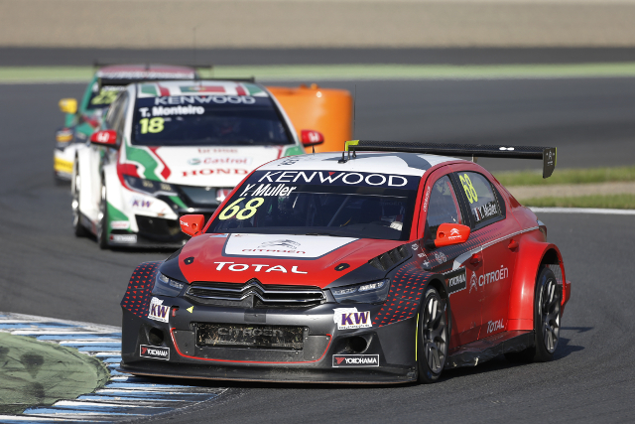

Yvan Muller in WTCC action

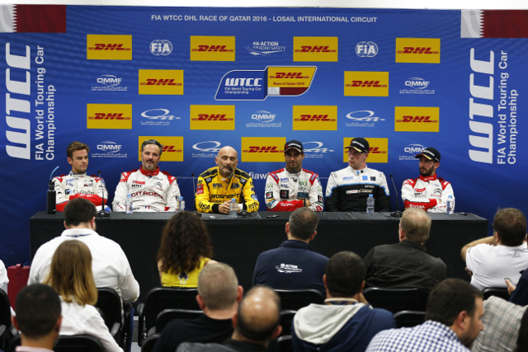

Winners and Heroes in WTCC Qatar

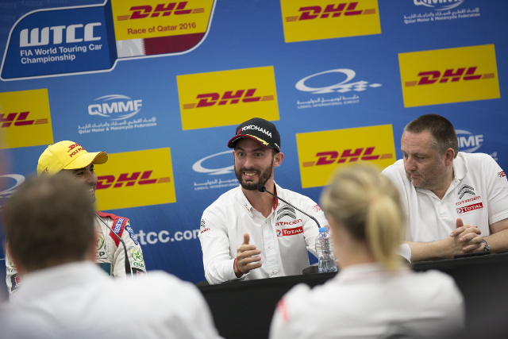

Champion Jose Maria Lopez in press conference

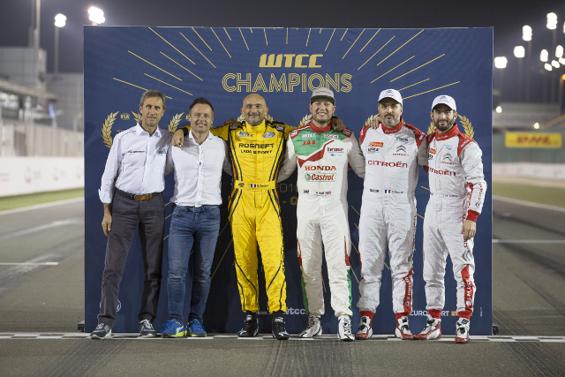

FIA WTCC Champions